GROUP BEHAVIOUR
UNIT – V
Foundations of group behaviour
The organizational objectives are later categorized into departmental objectives and group objectives. To accomplish the organizational objective, each group has to accomplish its group objective so that a “whole” can be achieved by co-ordinating various activities of groups. It is therefore division of work and coordination that provides synergy to the organization. A work group is collection of two or more individuals, working for a common goal and are interdependent. They interact significantly to achieve a group objective. For a manager it is difficult to manage group because of varied nature, personality traits, attitude of individuals and personal interest in the group job the group members display. It is therefore important for managers to understand group member behaviour and deal effectively with the group because of the synergy they provide. Manager should be able to achieve not only group objective but should be able to fulfil individual objectives within the overall organizational frame work.
Because of the joint efforts of the group, it possible to use skill, knowledge and experience of group members to achieve quality decisions and achieve group goals. Fred Luthans states that if a group exists in an organization, its members: – Are motivated to join
– Perceive a group as unified unit of interacting people
– Contribute to various amounts to the group processes
– Reach agreement and disagreements through various forms of interaction.
Types
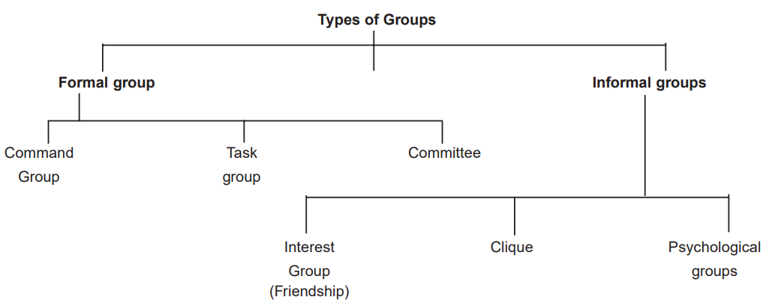
- Formal group
Formal group is designated work group defined by the organizational structure. It is collection of employees who work together to contribute towards achievement of organizational objective. For example aircrew.
- Command Group
Command groups involve a hierarchical structure wherein a member with a superior rank oversees other members. For example, the manager of a shop and his subordinate sales staff will become a command group. In a task group, members perform the same functions but they do not share a hierarchical command structure.
- Task Group
Formal groups are formed based on the work and human resources required by skill, knowledge and experience to achieve organizational task. In a manufacturing unit, the organizational task is sub divided into groups and teams. Each group is composed of various members based on the human resource requirement. The members of the group report to a designated leader. They interact with each other on official level.
- Committee
The other form of formal group is committee. It can be of permanent or temporary nature. Planning committee, finance committees are of permanent nature, they keep working all along and have a designated authority to control the work. There are temporary committees, which are formed to accomplish a one-time works like committees formed at district levels to issue identity cards to citizens. They are formed for specific work and disbanded once they have completed their work.
- Informal Groups
Informal groups are groups that are not formally organized in the work system to get the job done but develop on their own randomly at workplaces because of common interest and mutual liking of the group members. For example members of production department, body manufacturing department, HR department members and few individual from finance dept may form a friendship group. This development takes place because of the interaction they have with each other during the official work. Members from within one group or members from different departments or even an organization can form an informal group. The features of such groups are as under:
(a) Informal groups are formed by various members themselves, it has no official sanctity.
(b) These groups are formed based on commonality of culture, religious function, liking for each other and common interests.
(c) Their contribution for success of formal group is immense if properly handled by official authority.
(d) These groups evolve their own structure, elect their own leaders and have followers. They work based on group norms, social norms and code of conduct.
(e) They represent the human side of an organization.
(f) The group exist without any rigid rules. Their common interest is bond for existence.
- Friendship group. These are groups of people who have come together because they share common ideals, common interests or other similarities, like age or ethnic background.
- Clique/Interest group. An interest group is usually informal, and is a group of people who band together to attain a specific objective with which each member is concerned. Within an organization, this might be a group of people who come together to demand better working conditions or a better employee evaluation process. Outside of an organization, this term is frequently used in political situations to describe groups that give a point of view a voice. This includes groups like the National Rifle Association.
- Psychological Groups
When informal group members develop highest level of sentiments or affinity among themselves and become aware of each-others needs and potential contribution to further group objectives. These groups are called psychological groups. The distinct feature of such informal group is that the members become close knit, develops strong feeling of togetherness and get identified by the group. A feeling that ‘we’ belong to a particular group sets in deep into the behaviour pattern of all group members. At times the strength of informal group identity becomes so strong that the members are more loyal to their friendship group as compared to their normal group. The managers restructuring the task activities and using appropriate group processes should channel the emergent behaviours in such a way that will help organizations to achieve its goal. This phenomenon can be used effectively for the betterment of organizations.
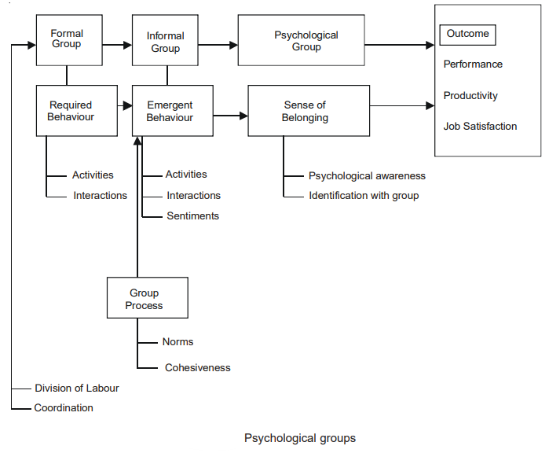
Functions
1. Assign Roles: Role is a set of expected behaviour attributed to someone who occupies a given position in a social unit. In formal groups, these roles are defined by job titles and positions. In informal groups, they are defined by their expectations and perceptions of other managers. Group members perform the following roles:
(i) Task-oriented roles: Members perform organisational tasks and keep other members focused on work.
(ii) Relations-oriented roles: They offer ideas and support other people’s ideas.
(iii) Self-oriented roles: These roles define personal expectations of members. They may or may not support the formal, task-oriented roles.
2. Group Norms and Conformity: Group norms are acceptable standards or expectations shared by group members. They relate to output levels, absenteeism, promptness, dress, loyalty, etc. Norms have powerful influence on performance. Members perform according to group norms.
Purpose of Group Norms
Group norms serve the following purposes:
(i) They define acceptable standards of behaviour.
(ii) They promote group cohesiveness.
(iii) They promote consistent, uniform and predictable behaviour.
(iv) They promote group discipline.
(v) They promote group culture as members interact with each other.
(vi) They provide order by restraining discretionary powers of members.
(vii) They ensure group effectiveness and survival.
3. Group Cohesiveness: Group cohesiveness is the degree to which members are attracted to the group and share the group goals. It is “the degree to which members are attracted to a group, are motivated to remain in the group, and are mutually influenced by one another.” Group cohesiveness has the following merits:
    - It strengthens group goals and group norms.
    - Cohesive groups perceive management as supportive to group goals. They perform better than less cohesive groups.
    - Members communicate freely and better understand the feelings, emotions and behaviour of others.
    - Members collectively engage in decision-making. This provides higher satisfaction than less cohesive groups.
    - Mutual trust and confidence develop strong inter-personal relationships.
    - Membership of cohesive groups is stable. Members accept innovations and change.
    - High compatibility between group goals and organisational goals motivates to perform better than less cohesive groups.
    - Members achieve higher job satisfaction than members of less cohesive groups.
    - Groups that perform similar activities do not depend on others to get the work done.
Group cohesiveness leads to positive consequences when members accept change in organisational policies. Group norms are high, resistance to change is low and people subordinate group goals in favour of organisational goals.
4. Group Decision-Making: Group decision-making is more effective as decisions are based on extensive information. Groups spend substantial time on finding problems, solutions and their implementation. Group decisions involve superiors and subordinates which develop diverse, open and new ideas.
5. Group Communication: Groups communicate through informal channels. Messages are clearly understood by members. There is effective feedback from group members which corrects misunderstanding. It is an important supplement to formal communication. Information gaps in formal communication are filled by informal channels. It promotes healthy inter-personal relationships and speeds up the flow of information.
Though rumours spread through informal channels, judicious use of this channel avoids gossips and rumours. Informal channels help to attain group goals, solve group problems, improve group performance, increase group cohesiveness and resolve group conflicts.
6. Informal leadership: Though formal leaders lead the group, informal leaders emerge by common consent of group members. They direct group activities. They are confident and assertive to perform.
(i) Task role: They help members to achieve the formal goals. They provide unity of action to group efforts. Sales manager, for example, assigns territories to sales people and supervises the new sales force members.
(ii) Group building and maintenance role: Leaders provide emotional, psychological and social support to group members. They build group image and strengthen their solidarity. They settle non-work related disputes and keep members attached to the group.
It is often difficult for the same person to perform both these roles. Different members, therefore, become leaders for different roles.
Factors Affecting Group Behaviour
Group behaviour defines the way people behave with each other. It explains the roles performed by members of the group. It reflects unity and commitment of members towards group and organisational goals. Group members empathise and actively interact with each other. Though groups expect the members to obey group norms, some difference in roles is evident. Differences develop novel and creative ideas.
1. Group size: Group size affects functions of the group. Smaller groups complete tasks faster than larger ones. They are more productive than large groups. Large groups, on the other hand, generate more facts, collect diverse and open viewpoints, and generate more solutions to problems. However, with increase in size of the group, contribution of individual member tends to decline. Responsibility for group goals gets dispersed amongst larger number of members. Relationship between individual input and group output cannot be maintained as group results cannot be attributed to single person. This reduces efficiency of the group. Large groups develop sub-groups, restrict participation by members, take time in making decisions, promote dominance by few etc.
What, then, is the optimum group size? It should be large enough to develop diverse viewpoints and small enough to fix responsibility and promote inter-personal interaction. Following points affect the optimum group size:
(i) Groups should have odd number of members. It eliminates ties when decisions are taken by vote. Odd number facilitates decision-making.
(ii) Usually five or seven makes the optimum size. It is neither too large nor too small. It allows diverse inputs and avoids negative outcomes of large groups.
2. Group composition: It represents the kind of individuals that make a group and affect its performance. Groups can be heterogeneous or homogeneous.
Heterogeneous groups have dissimilar individuals, in terms of age, gender, education, experience, skills, culture etc.
Homogeneous groups have similar individuals.
Heterogeneous groups are generally more effective as they have people with diverse skills and backgrounds. There may be conflicting opinions but they perform better than homogeneous groups.
3. Group goals and tasks: Groups are formed for some goals and perform tasks to achieve those goals. These goals promote cooperation and also result in role conflict. The tasks also vary in their skills, complexity, competence, etc.
These factors affect group performance in the following ways:
(i) Group size affects unity in group activities, formation of sub-groups, interaction amongst group members etc.
(ii) Group composition assigns roles to group members, affects quality of group leadership, group satisfaction etc.
(iii) Groups goals and tasks affect group decision-making, group communication, group cohesiveness etc.
Group Dynamics
Group dynamics is concerned with interaction and forces between group members in a social situation. Concept of group dynamics was first evolved by Kurt Lewin in 1930s who viewed the concept from the perspective of internal nature of group, why they form, how they form, the structure of group, how they function and its effect on other group members, other groups and the organization. Following concepts are relevant for the study of group dynamic. Group dynamics studies the nature, formation and reasons for forming the groups. It studies how groups affect the behaviour and attitude of members and the organisation. It is a process by which people interact with each other. If groups are effectively managed, they contribute a lot to organisational goals.
Stages of group development
The model of group development was first proposed by Bruce Tuckman in 1965. He presented a model of five stages of group development: Forming, Storming, Norming, Performing and Adjourning. Team progress through the stages is shown in the following diagram.
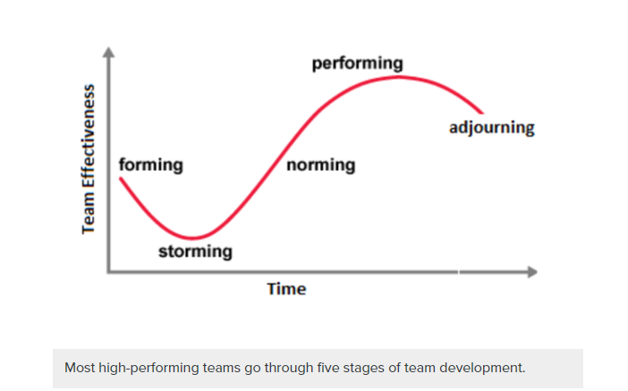
- Forming stage
The forming stage involves a period of orientation and getting acquainted. Uncertainty is high during this stage, and people are looking for leadership and authority. A member who asserts authority or is knowledgeable may be looked to take control. Team members are asking such questions as “What does the team offer me?” “What is expected of me?” “Will I fit in?” Most interactions are social as members get to know each other.
- Storming stage
The storming stage is the most difficult and critical stage to pass through. It is a period marked by conflict and competition as individual personalities emerge. Team performance may actually decrease in this stage because energy is put into unproductive activities. Members may disagree on team goals, and subgroups and cliques may form around strong personalities or areas of agreement. To get through this stage, members must work to overcome obstacles, to accept individual differences, and to work through conflicting ideas on team tasks and goals. Teams can get bogged down in this stage. Failure to address conflicts may result in long-term problems.
- Norming stage
If teams get through the storming stage, conflict is resolved and some degree of unity emerges. In the norming stage, consensus develops around who the leader or leaders are, and individual member’s roles. Interpersonal differences begin to be resolved, and a sense of cohesion and unity emerges. Team performance increases during this stage as members learn to cooperate and begin to focus on team goals. However, the harmony is precarious, and if disagreements re-emerge the team can slide back into storming.
- Performing stage
In the performing stage, consensus and cooperation have been well-established and the team is mature, organized, and well-functioning. There is a clear and stable structure, and members are committed to the team’s mission. Problems and conflicts still emerge, but they are dealt with constructively. The team is focused on problem solving and meeting team goals.
- Adjourning stage
In the adjourning stage, most of the team’s goals have been accomplished. The emphasis is on wrapping up final tasks and documenting the effort and results. As the work load is diminished, individual members may be reassigned to other teams, and the team disbands. There may be regret as the team ends, so a ceremonial acknowledgement of the work and success of the team can be helpful. If the team is a standing committee with ongoing responsibility, members may be replaced by new people and the team can go back to a forming or storming stage and repeat the development process.

Organizational Communication
Process
Organizational communication includes formal and informal communication throughout an organization, including communication among employees and employee-manager communication. The communication process involves the sender, transmission of a message through a selected channel and the receiver. Although the process of communication is more than the sum total of these elements, understanding them can help explain what happens when one person tries to express an idea to others.
1. Sender
The process of communication begins with a sender, the person who transmits a message. The branch manager explaining new product lines to the sales force, a computer programmer explaining a new program to a coworker, accountant giving financial report to its superior are all senders of communication.
2. Message
A message is any signal that triggers the response of a receiver. Messages could be verbal (written or spoken) or non-verbal (such as appearance, body language, silence, sounds, yawns, sighs etc.)
3. Encoding:
The sender must choose certain words or non-verbal methods to send an international message. This activity is called encoding. While encoding a message, one needs to consider what contents to include, how the receiver will interpret it and how it may affect one’s relationship.
4. Channel:
The choice of channel or medium (written or oral) is influenced by the interrelationships between the sender and the receiver. It also depends upon the urgency of the message being sent. Besides, one may consider factors such as importance, number of receivers, costs and amount of information.
5. Receiver:
A receiver is any person who notices and attaches some meaning to a message. In the best circumstances, a message reaches its intended receiver with no problems. In the confusing and imperfect world of business, however, several problems can occur. The message may never get to the receiver.
6. Decoding:
Even if the message reaches intact to its intended receiver, there is no guarantee that it will be understood as the sender intended it to be. The receiver must still decode it attaching meaning to the words or symbols. It may be noted that decoding is not always accurate. It depends upon individual experiences.
7. Feedback:
Ultimately, the receiver reacts or responds to the communication sent by the sender. The response could be based on clear interpretation of the symbols sent or it could be based on misunderstanding or misinterpretation of the symbols sent. Whatever the response of a receiver to a sender is, it is called feedback. Some feedback is non-verbal smiles, sighs, nods and so on.

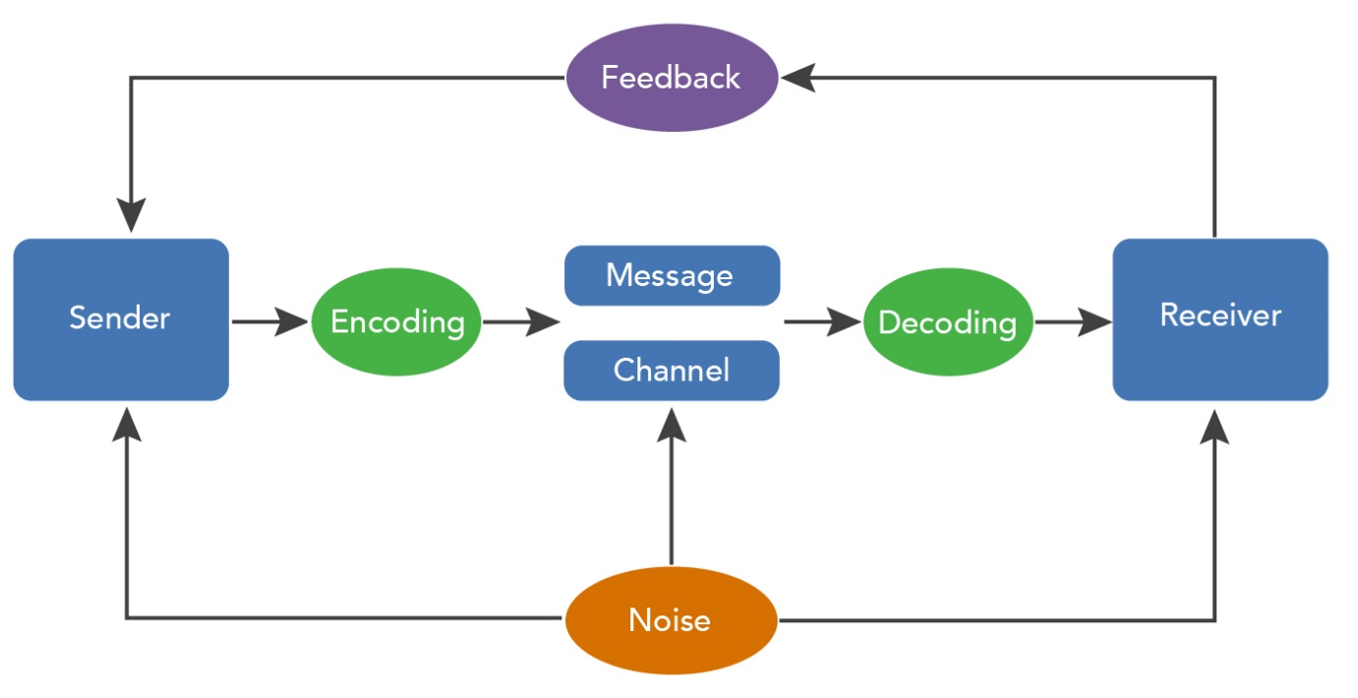
Types
An organization with communication needs should be able to use a broad range of communication mediums and styles. Here are four categories of organizational communication:
1. Formal and informal communication
The first consideration when classifying a type of organizational communication is whether the message is being delivered through official channels or not.
Formal communication
Formal communication covers any official company acts that share information. This can include communications such as a staff meeting to introduce a new product, a company handbook explaining standard operating procedures around an office or a press release distributed to the public. A company can still present a formal action more casually, such as through posts on their social media account.
Informal communication
Informal communication is any interaction outside of an official communication structure. For example, two employees having a conversation over lunch are participating in informal discussions. Informal communication is a key component of any company's organized communication structure.
2. Directional communication
When communicating within a company, the relative status of the parties in the interaction affects the dynamic of the communication.
Upward communication
Upward communication indicates how staff communicate with higher-ranking officials, such as an employee speaking with their manager. It's important for employees to understand the company's policies on addressing senior staff, and for the company to provide staff with methods of sharing any concerns or suggestions they have with higher-ranking members of the company.
Downward communication
Conversely, downward communication occurs when an employee is communicating with staff below them in the organizational structure. The goal of downward communication is usually to ensure the best work ethic for employees of every level, so it's important that the manager or senior official communicates respectfully with the employees for whom they're responsible.
Horizontal communication
Finally, horizontal communication occurs between two employees on the same level of the company hierarchy. This is often the most common form of communication in a business, with staff interacting with their peers and fellow team members throughout the day. Communication between staff members helps to build team morale, and it makes employees feel more comfortable offering or requesting help when needed.
3. Oral vs. written
Whether a company shares information through text or audio is an important consideration for any organizational communication. While both written and oral communication have their own diverse options, such as the difference between a company memo vs. a casual email between co-workers, or the difference between a staff meeting or a public relations video, each has some common key principles.
Oral communication
Oral communication gives you the opportunity to inflect while you speak, which makes for more dynamic interactions. With oral communication, however, it's especially important to make sure that the speaker communicates clearly to avoid any miscommunication.
Written communication
When using written communication, the most important distinction is the inability to present with tone. This can remove some nuance or subtlety from communications, making it more important that you choose your words carefully. Written communication often benefits from brevity, with shorter paragraphs and sentences better suited to maintaining the reader's interest.
4. Internal vs. external
The final consideration when communicating is whether you want to deliver your message internally to company employees or externally to the public.
Internal communication
Internal communication systems are integral to helping employees interact as effectively as possible, and they may also include more candid observations than public messaging. This practice allows you to provide employees with information without sharing any private or potentially negative information.
External communication
Strong external communication is essential to building a clientele and maintaining it. A business may have more stringent rules in place for external communication in order to help them maintain a more positive public image.
Barriers to Communication
1. Choice of Wrong Communication Medium
The choice of wrong communication medium is one of the most common communication barriers. The choice of communication medium need to correspond to the nature of the message. For example, giving negative feedback regarding any aspect of employee performance is better done through a verbal communication in a constructive way, rather than sending a letter or an e-mail.
2. Incorrect Use of Language
Incorrect use of language can also be specified as one of the major barriers to effective communication and this may relate to grammar, punctuation, spelling and a range of other issues.
3. Wrong Type of Message
Another significant barrier to communication may relate to inappropriate choice of the type of message. Complex instructions to employees need to be communication in written forms, whereas interpersonal and other conflicts are best resolved with oral communication.
4. Inappropriate Appearance of Message
Ineffective appearance of the message can also prove to be a communication barrier in organisational settings. Inappropriate appearance of the message is usually caused by its poor expression associated with readability, light print, omissions, ineffective sentence structure and others.
5. Use of Jargon
A range of occasions and reasons when jargons are used may relate to communicating with individuals within the same industry, unthinking use of jargons, attempts to impress the receiver(s) of message, altering the attention of receiver from certain facts and truths and others.
6. Emotional Barriers
The role of emotional barriers in communication is often underestimated by organisational managers. Emotional barriers may relate to specific emotional attachment in relation to communication topic, the choice of communication medium, or the sender or receiver of communication.
Emotional barriers in management-employee communications can be difficult to address due to two major reasons. Firstly, the emergence of emotional barriers is closely associated with temperament and personal traits and characteristics of individuals. Therefore, effective elimination of emotional barriers requires in-depth study of personalities. Secondly, occasions of emotional barriers in management-employee communications is often unnoticed by other individuals and higher level managers within the organisation, thus the employee may suffer in silence for a significant period of time with significant detrimental impacts both personally and professionally.
7. Physical Disabilities
Hearing problems and speech difficulties as the most common disability related issues that tend to create communication barriers. The scope of the issue associated with physical disabilities as a communication barrier in organisational settings might increase in the future in a global scale due to the increasing focus on providing equal opportunities to disabled people as an important organisational policy.
Overcoming barriers
To overcome communication barriers, the following methods may be followed by organizations:
1. Employee orientation:
If employees are given orientation about organizational objectives, policies, procedures, programmes, authority relations etc., communication barriers stand minimized significantly. This apart, employees are required to be communicated about vision, mission, goals, objectives, strategies, and if required, they need to be involved in developing the same. Such participation enhances commitment from employees and transparency makes them informed.
2. Improving interpersonal relations:
Improved interpersonal relations develop mutuality in organizations with employees becoming more cooperative and working together for accomplishing organizational goals. This requires superiors to respect the dignity and authority of their subordinates, which in turn develops the subordinates’ trust towards their superiors and eliminates status differences. Such an environment in an organization makes it possible for managers to communicate freely even through their personal contacts and make communication a truly two-way process.
3. Empathetic listening:
Due to typical managerial attitudes, quite often upward communication is greatly distorted. Managers often use their status and talk more in course of discussion with subordinates, without allowing them to express their feelings and emotions. Lack of such listening quite obviously creates barriers to communication, as managers evaluate information without getting the free and frank response from subordinates.
4. Using proper language:
Barriers to communication are often created due to semantic distortions. This can be avoided using direct and simple language in communication. Avoiding technical terms, words with more than one meaning, difficult symbols, etc. makes it possible to eliminate communication barriers.
5. Communication through actions:
Actions speak louder than words. When subordinates communicate and superiors do not act upon them, it sends back a wrong message, which dissuades future communication. The same thing happens when actions of superiors differ from what they say. This leads to a situation in which subordinates listen but do not act. Such barriers require to be eliminated through actions and deeds.
6. Judicious use of grapevine:
Grapevine is important for communication. But at times when managers depend too much on grapevine, ignoring official channels of communication, it develops a culture of informal communication and thereby creates barriers to communication. Hence, grapevine needs to be judiciously used.
7. Lack of information feedback:
Communication is essentially a two-way process. Hence, feedback is very important. When there is no information feedback, it creates barriers to communication. Even in face-to-face communication, body language may provide a successful feedback.
Organizational Conflict
Concept and nature of organizational conflict
A conflict is a situation when there is a misunderstanding between two or more individuals either in terms of goals, attitudes, interests, needs, beliefs, roles, or other aspects. In organizational settings, such conflicts are known as organizational conflicts or workplace conflicts. Conflicts are common in organizations. Whenever two employees or a group of employees differ in their goals or understanding conflicts arise in the workplace.
It is the responsibility of organizations to cultivate an atmosphere at work that fosters the growth and development of their employees. If there is an escalation of disagreement and differences of opinion into conflict, then the organization is obligated to take immediate action. A conflict within an organization has the potential to be either beneficial or harmful to the organization. Relationships between individuals and groups in their workplaces, as well as in other aspects of life, can be improved through effective management of conflict.
Transactional analysis
When people interact with each other, the social transaction gets created which shows how people are responding and behaving with each other, the study of such transactions between people is called as the transactional analysis. The Transactional Analysis refers to the psychoanalytic process wherein the interpersonal behaviours are studied. In other words, a social psychological model that talks about the personal growth and personal change, i.e., identifying the ego states of each individual to understand their behaviours and altering them to solve the emotional problems. This model was originally developed by Dr Eric Berne, who during his observation found that his patients behaved in a way as if several different people were inside them. This forced him to study the personality and dynamics of self and its relationship with others which helped in determining the kinds of behaviours that an individual shows in different real time situations. Dr. Berne developed transactional analysis to focus on behaviour as a communication. Each type of behaviour has a payoff for you and others regarding how you feel about yourself, how others think of you, or both.
The transactional analysis gives birth to several models that help in explaining the relationship formed between the individuals as a result of their interactions. It mainly involves:
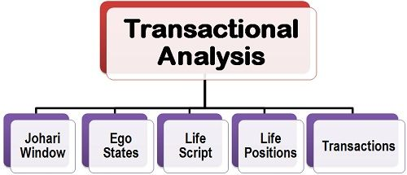
TA assumes that every person has three ego states:
- Parent
- Adult
- Child
These ego states represent different aspects of our personality, beliefs, and behaviours.
The parent ego state is influenced by the rules and values we learned from our parents or authority figures. A parent state is one in which your greatest desire is to make someone else happy.
The adult ego state is based on rational thinking and problem-solving. The adult state is one in which you are neither too defensive nor rational nor too emotionally reactive to think clearly.
The child ego state is driven by emotions, impulses, and needs. This state is characterized by feelings of no control over one’s life.
TA also proposes that every communication between two people is a transaction, which can be complementary, crossed, or ulterior.
A person in a child state will feel like their life is ruled by someone else, so they’ll react passively to events and will typically follow orders. They are also likely to be very emotional because they don’t have enough information about what’s going on around them to understand why things are happening.
Because of these feelings, people in a child state will seek authority figures—usually parents—to take care of them and tell them what to do next.
In business settings, employees stuck in a child state might need their manager to make all their decisions for them or need constant reassurance from above that everything is going according to plan.
If you work with people who fall into this category, it can be helpful for you as an employer or manager if you know how best to handle them.
Analysis of self
Individual self-analysis appears worthy to procure several insights, including strengths and weaknesses. Based on these insights, an individual can make improvements and become a better leader or manager in the future.
- It is a systematic approach taken by every individual to evaluate their strength and weakness at physical, intellectual as well as at an emotional level.
- It involves a wide variety of mechanism and technique to understand one’s thought and behaviour.
- Self-awareness is very important aspects in order to develop one’s identity.
- The process involves an understanding or comprehension of the individual’s subconscious and conscious mind.
Organizational Culture
Concept
Organizational culture is the set of values, beliefs, attitudes, systems, and rules that outline and influence employee behaviour within an organization. The culture reflects how employees, customers, vendors, and stakeholders experience the organization and its brand. Organizational culture affects all aspects of your business, from punctuality and tone to contract terms and employee benefits.
Organizational change concept
Organizational change refers to the actions in which a company or business alters a major component of its organization, such as its culture, the underlying technologies or infrastructure it uses to operate, or its internal processes. Organizational change management is the process of guiding organizational change to a successful resolution, and it typically includes three major phases: preparation, implementation, and follow-through.
Many factors make organizational change necessary. Some of the most common faced by managers include:
- New leadership at the helm of the company or within its departments
- Shifts in the organizational team structure
- The implementation of new technology
- The adoption of new business models
To ensure a smooth transition, it’s important to have a set organizational change management process that can be applied across various types of change.
TYPES OF ORGANIZATIONAL CHANGE
- Adaptive changes are small, incremental changes organizations adopt to address needs that evolve over time. Typically, these changes are minor modifications and adjustments that managers fine-tune and implement to execute upon business strategies. Throughout the process, leadership may add, subtract, or refine processes.
- Transformational changes have a larger scale and scope than adaptive changes. They can often involve a simultaneous shift in mission and strategy, company or team structure, people and organizational performance, or business processes. Because of their scale, these changes often take a substantial amount of time and energy to enact.

-----------------------------------------------------------------------------------------

